
“An information exchange for the Department for Workforce Investment”
Produced by the Office of Employment and Training
Volume 7 , Issue 1 October 21, 2005

New Version of EKOS (v3.4)

EKOS was taken down on Thursday, October 20 in order to begin the load process for v3.4 into Mediated Production and will remain down until Monday, October 24. If you encounter problems accessing the new version please contact the Cabinet Helpdesk toll free at 866-520-0002 or locally at 564-9216. You can also contact the EKOS Support Helpdesk staff at: ekos.project@ky.gov.

Whenever a new version is implemented you must reinstall EKOS onto your computer. You will be prompted to install the new version when you sign on and click on the update button. See instructions below:

Click on the 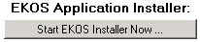 button. Once this process is completed click on to finish the procedure. Afterwards each time you sign on you will only need to click on the link. Once installed you should have the latest version of EKOS (V3.4.03) loaded onto your computer. After clicking on the daily update link if you experience any problems please try clicking on the 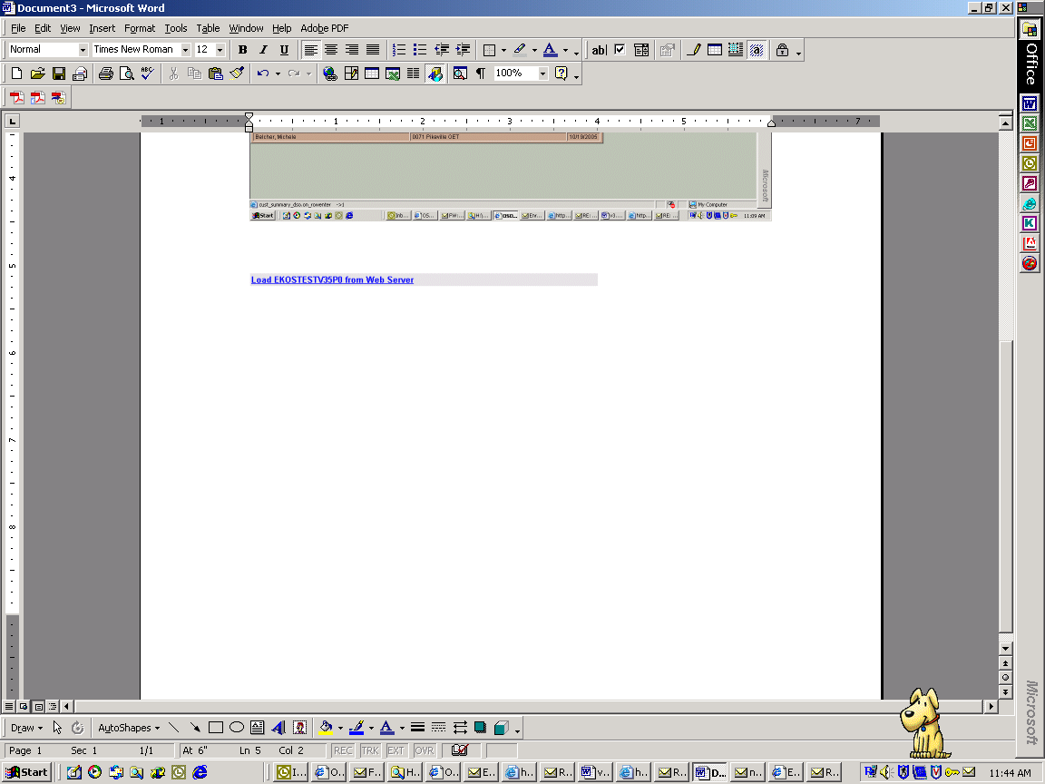 link.

Logging on to EKOS
There is a slight change in the initial login process for v3.4. Once the software has been loaded onto your computer, the following screen will appear (See screen shot # 1). Staff will need to type in their username and password and then click on the Login button.

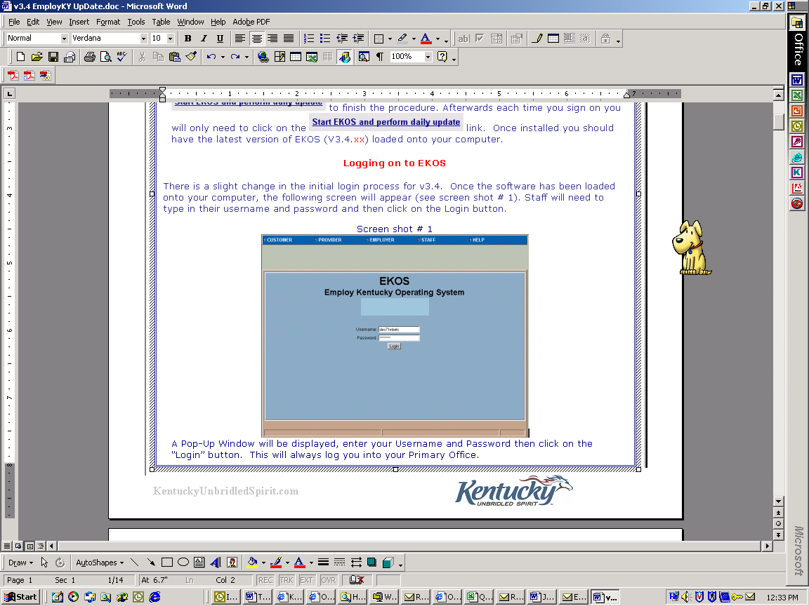

A Pop-Up Window will be displayed, enter your Username and Password then click on the “Login” button. This will always log you into your Primary Office.

Enhancements
This version of EKOS is bringing many changes to the system, which will be explained, on the following pages.

Employ Kentucky Update
Screen shot # 1

Volume 7 , Issue 1 , Page 2 EMPLOYKY UPDATE Training DeskAid October 21 , 2005

Common Measures General Information
This version of EKOS brings many changes that are occurring due to Common Measures. These changes will be identified on the following pages. Along with the actual changes to the EKOS, Common Measures is bringing about a new concept regarding performance standards.

- Common Measures reporting system calculates performance outcomes based on an exit quarter and no longer allows hard exits.
- A customer is referred to as a participant. A participant is someone who has been determined eligible to participate and who receives a program funded-service in a physical location (one of our offices not via the Internet).
- Performance outcomes will now be reported based on the participant's overall service period instead of individual programs.
- Labor Exchange participants do not count in performance until they exit. In WIA, youth skill attainment and Numeracy/Literacy are based on outcomes during participation, not at exit.
- To be excluded from performance calculations, the condition(s) must be expected to last 90 days or more. These exclusion conditions from all common measures are:
    - Persons institutionalized (exceptions are detained Responsible Reintegration of Youthful Offenders and disabled individuals residing in institutions).
    - Persons unable to continue due to health/medical or family care reasons.
    - Deceased.
    - Reservists called to active duty.
    - Relocated to a mandated residential program (youth only)

Customer Search Module
There have been a few changes to the Customer Search Module within EKOS.

The Skills tab has been renamed ‘Activities’. (See screen shot #2)
- This tab is currently exclusive and can’t be used with any other search criteria placed on the other tabs. Once this has been changed staff will be notified.
- Staff can now search for participants who have been served by particular staff members, the activity(s) and a specific date range of the activity. (See screen shot #2)
- Using the ‘Shift’ key staff can select multiple activities, located within one group, to search by.
- Using the ‘Alt’ key staff can select multiple activities, located within multiple groups, to search by.

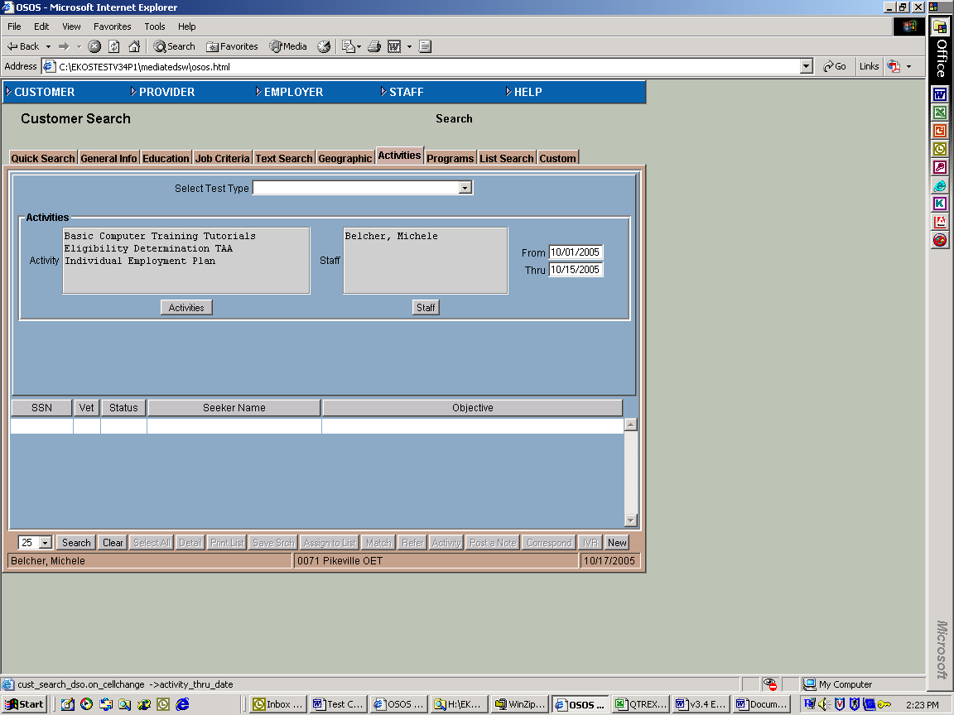

Employ Kentucky Update
Screen shot # 2

Volume 7 , Issue 1 , Page 3 EMPLOYKY UPDATE Training DeskAid October 21 , 2005

Customer Module
The following changes have been made within the Customer Module.

Gen. Info. Tab
- Customer Data Section has a new field labeled ‘N/A’ that is being provided to identify any participant that does not have an actual SSN. (See screen shot # 3)
- Participants with a Pseudo SSN will be excluded from performance.
- A checkmark in this field indicates that the SSN is a pseudo SSN.
      - The pseudo SSN should start with a 9 then the 2nd and 3rd numbers should identify the local office (example: 0060 would be 60), the 4th and 5th numbers should be the participant’s birth year (example: 2005 would be 05). The 6th and 7th numbers should be the participant’s
birth month (example: February (2) would be 02). The 8th and 9th numbers should be the participant’s birth day (example: 9 would be 09). The pseudo SSN number for the above example would be 960-05-0209.
- The ‘Status’ and ‘Job Seeker’ fields are not attached to the 90-day common measures exit date so once it has been determined that a participant has been exited on the Customer Services Module / Enrollments Tab staff need to update these two fields on the Customer Module / Gen Info Tab.
- Education & Employment Section (See screen shot # 3)
- The ‘Education Level’ field has been updated to include cross edit checks. EKOS has been modified to capture the highest grade completed when setting WIA logging enrollment and exiting characteristics.
- The ‘In School’ field has been renamed to ‘School Status’ and contains the updated and additional values of: ‘In School, HS or less’; ‘In School, Alternative School’; ‘In School, Post HS’; ‘Not attending school or HS drop out’; and ‘Not attending school, HS Graduate’.
- The ‘Weeks not Employed at Registration’ has been removed.
- The ‘Employed’ field has been renamed ‘Employment Status’ and is now a drop-down list with the following values: ‘Employed’; ‘Employed, but Rcvd Notice of Termination’; and ‘Not Employed. The ‘Employed, but Rcvd Notice of Termination’ should be selected for any customer that received a WARN Notice. This field should be updated as needed whenever the customer’s information changes.

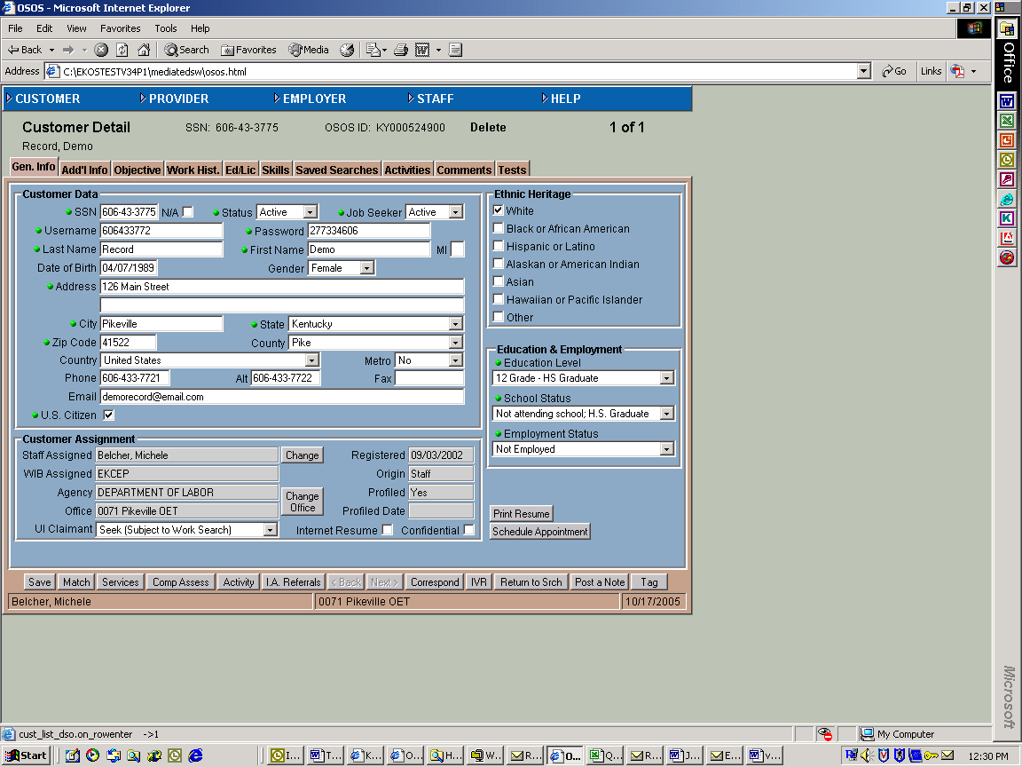

Employ Kentucky Update
Screen Shot # 3

Volume 7 , Issue 1 , Page 4 EMPLOYKY UPDATE Training DeskAid October 21 , 2005

Add’l Info. Tab
- Programs Section
- Programs/Public Assistance Selection button
- Staff should mark only the items displayed under the “Programs” and “Public Assistance” headings if they are the staff to provide the service and have verified the data. This is a change from previous training.
- Whenever the participant has indicated an interest in one or more of the services listed below the “Interested in these One-Stop Services” (located in the left column on the screen) staff should indicate a ‘yes’ along with the date the participant has indicated the interest.
- Although the items displayed are not green dotted, if appropriate, they must be completed because they are required for various reports.
- In the Programs section staff should not select ‘UI – 599 Unemployment Insurance’ if the customer is receiving Unemployment Insurance benefits. KY does not have this program. Staff should select ‘UI—Unemployment Insurance’.
- There has been several changes within the Programs Section (left column)
  - ‘Migrant/Seasonal Worker Programs’ has been renamed to ‘National Farmworker Jobs Program’.
  - ‘Employment & Training HUD’ has been removed.
  - ‘Youth Build’ as been added as a new program.
- Customer Disability Status field
  - The ‘Disable with imped’ choice has been removed.
- Military Service Section (See screen shot # 4)
- A new field labeled ‘Current Housing’ has been added. The drop down list for this field has the following values: Foster Child, Homeless, Own Home, Rent, Runaway, and Mobile Home. These values automatically populate into the appropriate areas in the Services and Comp Assessment Modules.

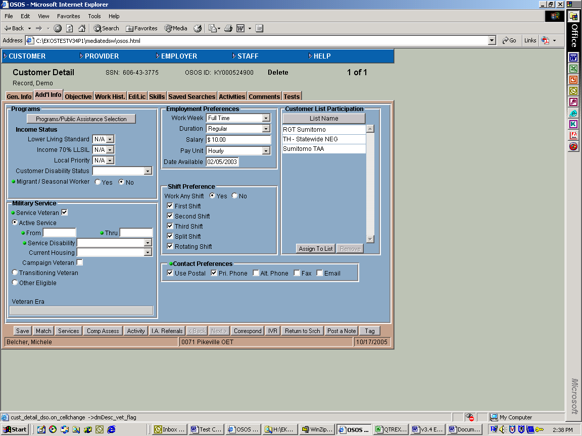
Screen Shot # 4

Activities Button
- There have been various additions and deletions to the customer activities. (See screen shot # 4)
- The Department of Labor / Informational/Self-Service activity group has changed
  - ‘Access to Resource Room’, ‘Assistance Accessing Internet’, ‘Availability of Supportive Services’, ‘Help using Self-Service Systems’, and ‘Info on Filing UI Claims, Eligibility for

Employ Kentucky Update

Volume 7 , Issue 1 , Page 5 EMPLOYKY UPDATE Training DeskAid October 21 , 2005

WTW, Financial Aid…..’ were removed. These were replaced with ‘Utilizing Resource Rooms’, which is to be collected to track Self Service.
    - ‘Specific Labor Market Information’ is renamed ‘Workforce Information Services’. This will appear as Self Service and Staff Assisted.
    - ‘Self-Service Job Matching’ will remain and track self-service. It can be chosen by a participant on self-registration and populate EKOS. It does not generate a Labor Exchange Enrollment.
- EKOS is a common system, which is used by multiple partners. Whenever staff provides a service to a participant they should attach the appropriate activity to the record. Therefore, multiple partners may attach the same activity to the participant record. (Example: During Rapid Response Orientation multiple partners are present and may provide the same service to the participant but the service each provide will pertain to their individual programs which is why the same activity may be attached to a record by different staff).
- Every time a 9002 activity is attached to the participant record that has been soft exited, a new common measures enrollment will be activated.
- State Specific and other non-9002 activities do not create an enrollment on the Customer Services Module / Enrollments Tab.
- When EKOS was first implemented staff were told that they could only use activities listed under certain headings. This is no longer true. If an activity that you provide to a participant is listed under a different heading you can now use it.
- Labor Exchange Reportable activities need to be attached to a participant’s record if the participant is to be counted in performance.
- State Specific activities are used to track information that is needed for state reports.

Customer Comprehensive Assessment Module

Housing Tab
Foster Child is a new reporting category on the WIASRD. If staff is assisting a foster child then ‘Foster Child’ should be selected in the drop down list of the Current Housing field.

Customer Services Module
The following changes have been made to the Customer Services Module.

Achievement Objectives Tab
The Holds Section previously located on this tab has been relocated to the Outcomes Tab.

Services Tab
- When clicking on the ‘New Service’ button, a search Offering screen is displayed. There has been new Service Type offerings added that could be attached to the participant record. They are: ‘Disaster Relief Assistance’ (for NEG’s), ‘Participation in ATAA’, ‘Transition Assistance Program Workshop (TAP), TRA Remedial, and ‘Workforce Information Services Self-Service (LMI)’ and ‘Workforce Information Services Staff Assisted (LMI)’.
- When funding is attached to a service there are several fields that are required, although they are not green dotted. If staff try to save the record without these fields being completed they will receive an error message. These fields are: ‘Planned End Date’ and ‘Program Svc Type’.
- A new ‘Number of Weeks’ field has been added to the Services Module / Services Tab / Detail section to capture the number of weeks a participant received Trade Relocation Allowance (TRA). It is only available when the seeker service category of Trade Act Allowances has been attached to the
Participant’s record. If this service is not attached to the record then this field will display as disabled (which will not allow staff to enter data into the field). (See screen shot # 5)
- The ‘Waiver From Training’ checkbox field displayed in the Services Module / Services Tab / Funding section has been modified to display as a drop-down list and re-labeled as ‘Training Waiver’. (See screen shot # 5)

Employ Kentucky Update

Volume 7 , Issue 1 , Page 6 EMPLOYKY UPDATE Training DeskAid October 21 , 2005

    - The drop-down list has the following values: ‘Recall’; ‘Marketable Skills’; ‘Retirement’; ‘Health’; ‘Enrollment Unavailable’; ‘Training Not Available’; and ‘Yes’. All of these values can be selected to identify why the participant was placed on the waiver except ‘yes’. The ‘yes’ value is displayed in red and is only used to convert pre-Common Measures selections.
    - Any changes made to this field can now be tracked on the Audit Tab.

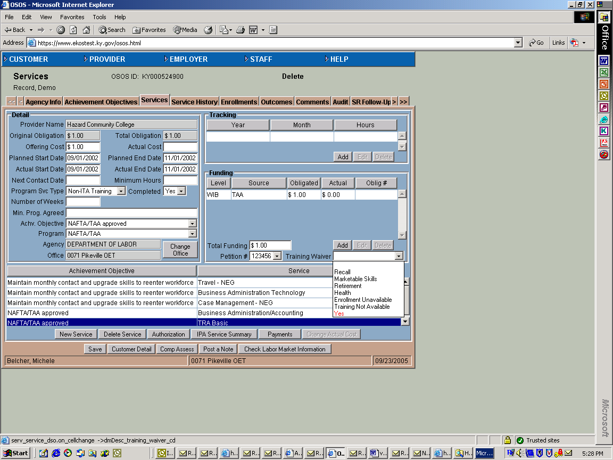
Screen Shot # 5

Enrollments Tab
- The Enrollments Tab has a new look, as many fields have been changed. This tab now consists of two separate sections identified as the Enrollment Info section and the Exit Info section. This tab is used to manage exits for a participant’s various partner program enrollments such as Common Measures, WIA, Trade Act, NEG’s and other state specific funding programs. Each of the
participant’s partner program enrollment periods are displayed in the list at the bottom of the screen. Clicking on a program enrollment entry in this list will display its detail information in the Enrollment Info and Exit Info sections above the list. (See screen shot # 6)
- EKOS has been modified to incorporate a parent, child and singleton enrollments. A Common Measures program type has been added that creates a parent enrollment whose function is to cluster a set of child enrollments with a common point of exit and common outcomes. Then when enrollments are created, enrollment data and enrollment characteristics are captured and propagated to a parent.
    - A child enrollment shall be defined as the enrolling service or activity if a Common Measures parent enrollment is required.
  - Each child enrollment shall have its own set of enrolling characteristics that is created at the point of time the enrollment is created.
    - If a parent enrollment is not required, an enrolling service or activity shall create a ‘singleton’ enrollment.
- If two separate programs provide assistance at the same time and an activity and a service is attached to the participant record the activity date is the lead because the system assumes that activities are entered prior to services being provided and attached to the customer record.
- Using the Services screen to attach WIA or Trade Act funds to fund a participant’s service creates the Common Measures, WIA and Trade Act enrollments. Labor Exchange enrollments are initiated by adding Labor Exchange Activities in the Customer Module. NEG funded services create Common Measures and NEG enrollments.

Employ Kentucky Update

Volume 7 , Issue 1 , Page 7 EMPLOYKY UPDATE Training DeskAid October 21 , 2005

    - The Enrollment Info Section (See screen shot # 6)
    - "Enrolled in Education" is a new field used to capture if the participant is enrolled in education during the enrollment period, either at registration or any time during participation.
    - The ‘Holds’ section previously located on the Achievement Objective tab has been moved to this tab.
  - The hold periods have been converted to unique enrollment hold periods and are only allowed on parent and singleton enrollments.
  - Existing Achievement Obj. hold periods have been converted to unique enrollment hold periods.
  - Participants who are expected to have a gap in service of more than 90 days for specific reasons, a hold can be placed on the parent or singleton enrollment to keep the participant from being exited, which will stop the 90-day clock.
  - Participants can only be placed on hold for the following reasons: delay before start of training, health/medical or family care, or temporary move from area.
- The Exit Info Section (See screen shot # 6)
    - “The term program exit means a participant does not receive a service (or activity) funded by the program or partner program for 90 consecutive calendar days and is not scheduled for future services” as per TEGL-28-04.
    - If the participant record has an existing enrollment exit date attached to the record and staff try to attach a customer activity an error message will be generated.
    - If the participant record has an existing enrollment exit date attached to the record and it is past the 90 days, if staff enter another activity a new enrollment will be created.
    - The exit date field is system generated and read-only (disabled). Ninety days from the last closed service or activity date, the system will generate an exit date with exit reason ‘exited after 90 days’. Staff can modify the exit reason. The only instances where staff should enter an exit reason is for exclusion reasons.
  - When the system enters a soft exit this date will be based on the maximum Service Actual End Date or Activity c-time. When a parent enrollment (Common Measures) is exited, the exit data will automatically populate all the children enrollments of this enrollment.
    - Staff can no longer enter a hard exit date to a customer record unless it meets one of the five exclusion reasons given by DOL. (See the Common Measures General Information section on page 2). If one of the exclusion reasons has been attached to the participant record then EKOS will not pull the record for performance until the 90-day clock expires.
    - If an exit reason is entered before 90 days and saved, the system will generate a date of last service end date or 9002-activity date, whichever is the latest. Even though a date is generated
in the exit date field, the participant exit record will not be official and will not be pulled for reporting or performance purposes until 90 days from the exit date has passed.
    - If a participant who has a hard exit entered for exclusion reasons comes back in for services or activities with the 90 days, EKOS will not allow additional services or activities to be attached to the participant record. Outcomes and enrollment exit information must be backed out of the system before the participant can be served. Only super-users will have the authority to back out an exit date. If OET staff backs out a hard exit, they must notify the staff that entered the hard exit.
    - If for any reason an exit date must be backed out of the system staff must contact the WIA case manager by phone to do so and also send an IA Referral. If the WIA case manager is not
available then OET staff with the proper security clearance can back out the exit date and must also send an IA Referral to the WIA case manager. The IA Referral will also be attached to the record for future reference.
    - The Exit Reason drop-down list has several changes to it.
  - New exit reasons ‘relocated to mandated residential program’ and family care. ‘Relocated to Mandated Residential Program’ is defined as ‘youth is in foster care system or any other mandated residential program and has moved from the areas as part of the such program’. ‘Family Care’ is defined as ‘if the participant is providing care for a family member that

Employ Kentucky Update

Volume 7 , Issue 1 , Page 8 EMPLOYKY UPDATE Training DeskAid October 20 , 2005

precludes entry into unsubsidized employment or continued participation in the program. Does not include temporary conditions expected to last for less than 90 days.
  - ‘Cannot locate’ is replaced with ‘moved from area/cannot locate’.
  - ‘Death’ is renamed ‘deceased’.
  - ‘Entered Advanced Training (Youth Only)’ ‘Entered Military (Youth Only)’; ‘Entered Post-Secondary Training’; ‘Entered Qualified Apprenticeship (Youth)’; are no longer available (disabled) and appear in the list in red. These have become required fields on the Outcomes tab for performance purposes.
  - ‘Other’ is replaced by ‘other reason for exit’.
  - ‘Terminated after 90 days’ is replaced with ‘Exited after 90 days’.
  - ‘Voluntarily withdrew’ is replaced with ‘voluntary exit’.
    - A new field labeled ‘3rd Qtr Exclusion’ has been added.
  - This field is used to exclude participants from Common Measures either at the time of exit or during the three-quarter-measurement period following the exit quarter.
  - The drop-down list values are ‘null’, ‘deceased’, ‘family care’, ‘institutionalized’, ‘health/medical’, ‘reservist called to active duty’, and ‘relocated to mandated residential program (youth only)’.
  - This field is displayed as read-only until the enrollment is exited.
    - New Transaction fields have been added: Transaction Date, Transaction Admin and Transaction Office which will be populated if staff enters a hard exit using an exclusion reason.

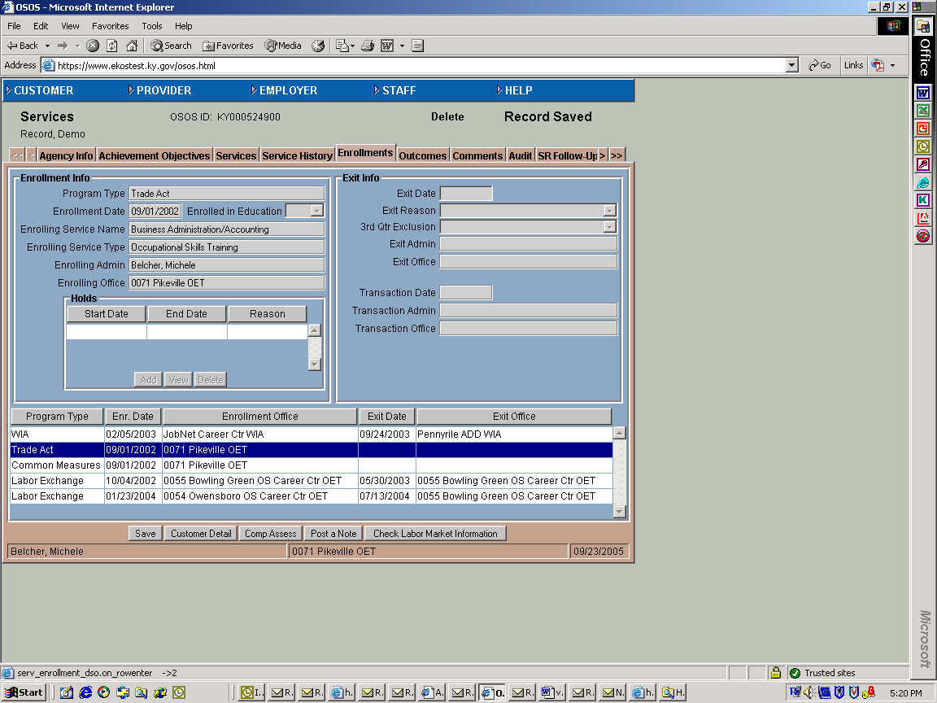
Screen shot # 6

Outcomes Tab
- The Outcomes tab of Customer Services Module has been modified to prevent incorrect data from being entered. “UI Wage Record Data” can no longer be manually selected for the “employed in quarter after exit” fields. Staff will not be allowed to overwrite values, selected through the Wage Data Interface, for the “employed in quarter after exit” field and the associated Determination field if the Determination Method is equal to “UI Wage Record Data”. If the Determination Method is not equal to “UI Wage Record Data”, then staff will be allowed to change the field. (See screen shot # 7)
- The system will allow outcomes to be entered and saved without the exit date. Information such as Attained Credential, high school diploma, etc. is based on “by the end of 1st, 3rd quarter”, so it could
be entered before the system sets a soft exit. Outcomes based on “In the 1st, 2nd or 3rd quarter” cannot be entered until the system has soft exited the participant in order to know time parameters for post-quarters. Example: John Doe completed all WIA services on 07-01-2005, received his last Labor Exchange 9002 activity on 07-30-2005, and became employed on 09-05-2005. Assuming John would receive no other services, the WIA case manager enters “Yes” for employed in Quarter after Exit using “supplemental” as the determination method. On 09-29-2005 John looses his job and comes back into the One-Stop for staff assisted job search. The Quarter after Exit outcome information is no longer valid.

Employ Kentucky Update

Volume 7 , Issue 1 , Page 9 EMPLOYKY UPDATE Training DeskAid October 21 , 2005

- The ‘Education Level at Exit’ field in the Education & Training section and the ‘School Status at Exit’ field in the Youth Outcomes section must match on Youth records otherwise an error message will be generated.
- Employment section (See screen shot # 7)
- In the ‘Employment Training Related’ field ‘Determination Method’ has been removed.
- The Education & Training section (See screen shot # 7)
- This section is required for Youth
- This section also has a new field labeled ‘Education Level at Exit’.
- The ‘Type of Credential’ drop-down list has a new value labeled ‘Other Recog. Edu/Occ Skills Cred/Cert.’
- The Employed in Quarter after Exit section (See screen shot # 7)
- The ‘2nd Quarter’ and ‘4th Quarter’ fields are new fields added for WIA programs.
- The Youth Outcomes section will only display on youth customers. The ‘WIA Youth Follow Up fields are located when staff click on the ‘WIA Youth’ button. This section has a new field labeled ‘Attained Cert. Of Technical/Occ. Skills (See screen shots # 7 and 7a)

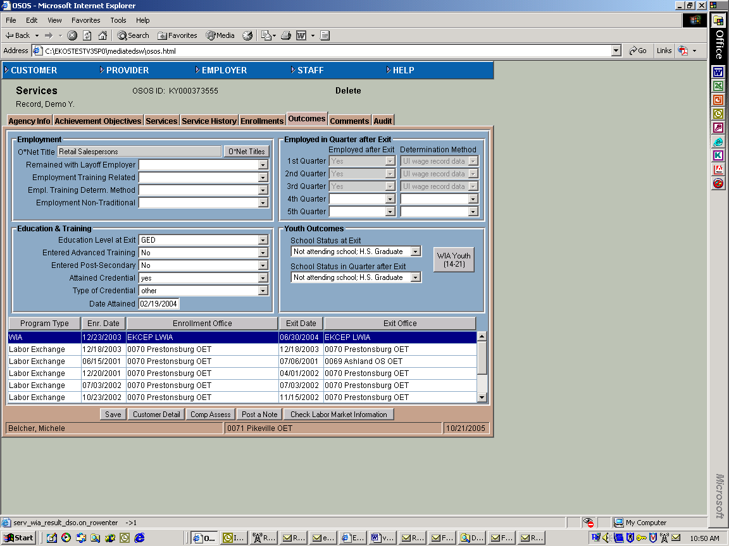

Screen shot # 7a
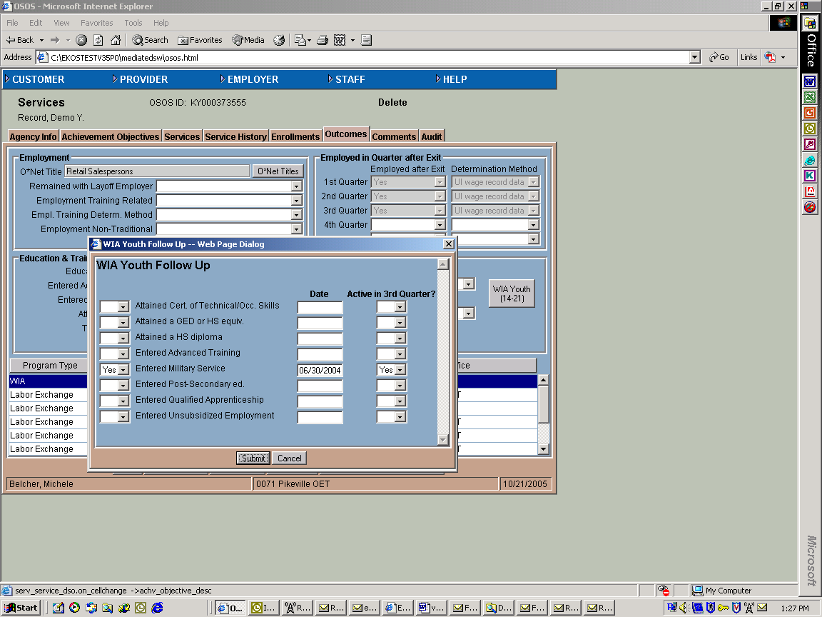
Screen shot # 7

Lit/Num Custom Tab
A new tab in the Service Module has been developed to capture information for the WIA Youth Common Measure Numeracy and Literacy Gains. (See screen shot # 8)
- The Enrollment section identifies all programs the participant is enrolled into. Staff will click on the WIA Program Enrollment and the Add Button will be available to enter testing information. Each functional area test will be entered separately, with identifying information, pre and post test information.
- The enrollment date is system generated with the WIA program enrollment date.
- Staff security clearance for this tab is included in their clearance for the entire services module. Example: If staff has add/delete clearance for the Services Module Achievement Objective tab, they have the same clearance of Num/Lit tab.

Employ Kentucky Update

Volume 7 , Issue 1 , Page 10 EMPLOYKY UPDATE Training DeskAid October 21 , 2005

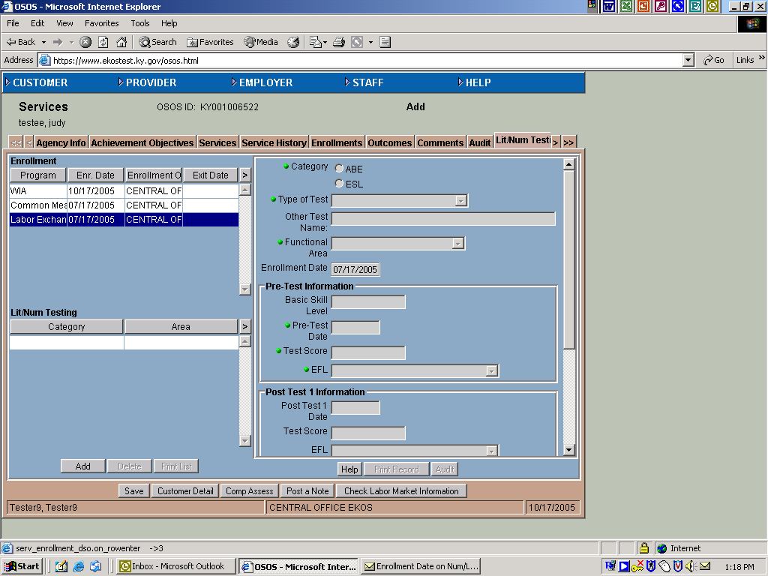
Screen shot # 8

Employer Activities
- This version of EKOS has a new format for URL's and email addresses to match the AJB format. Staff will need to update any improperly formatted URL's and email addresses, as needed, when they appear in red on the employer detail, employer contact page, customer detail, or customer self service screens.
- EKOS has been modified to automatically create a “Job Order Taking” activity in the Employer Detail Module when a new job order has been entered and saved. (See Screen Shot #9)

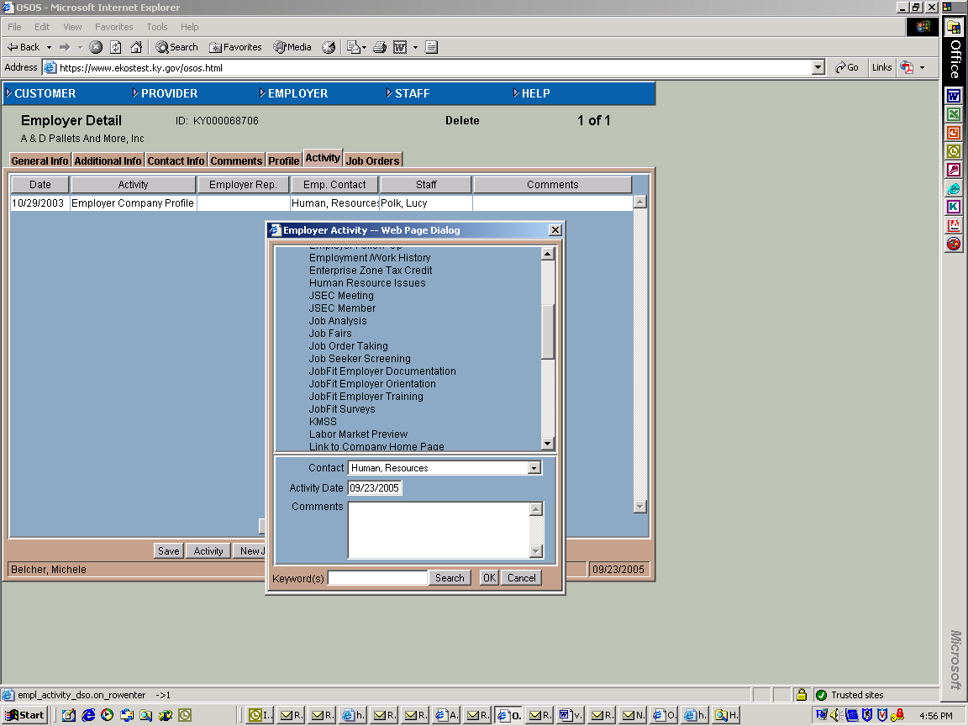
Screen shot # 9

Employ Kentucky Update

Volume 7 , Issue 1 , Page 11 EMPLOYKY UPDATE Training DeskAid October 21 , 2005

Job Order Searches
Staff can now search on job orders based on their method of origin into EKOS. America’s Job Bank (AJB) job orders are split into three methods based on how the jobs were entered into the AJB site. The Origination drop down list values has been modified to improve clarity. (See Screen Shot # 10)

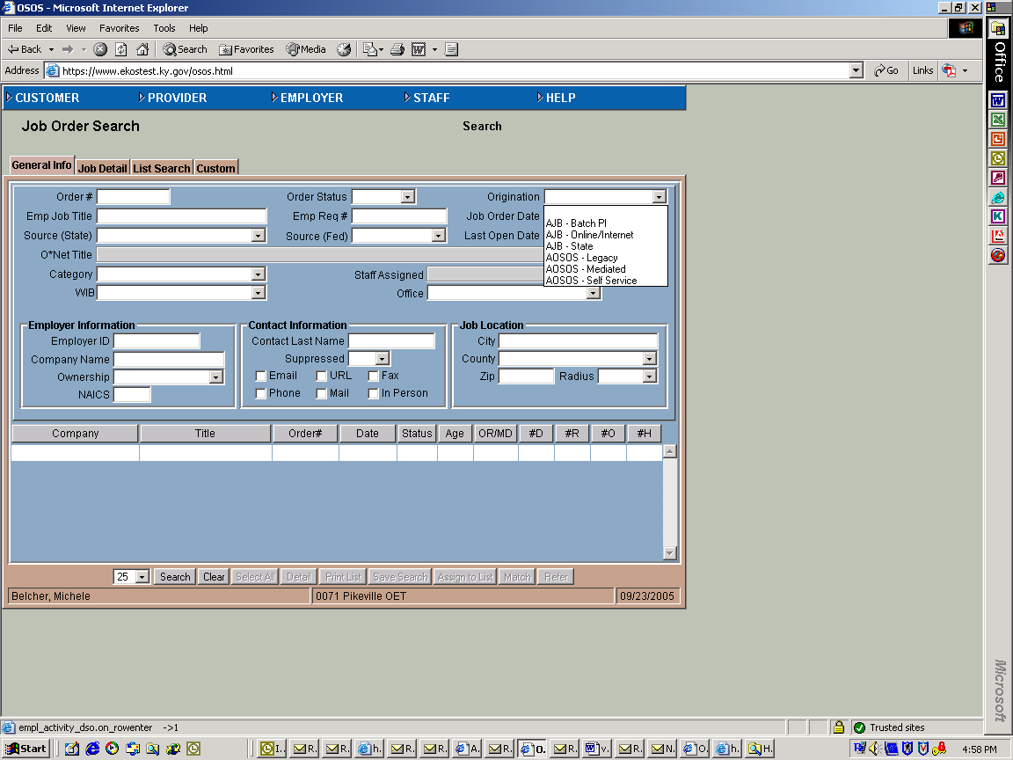
Screen shot # 10

Staff Inbox Reminders
A 30-day soft exit reminder and a reminder the day after the participant’s exits the program will populate the WIA Staff Inbox.

ABOUT THIS PUBLICATION
Produced by the Office for Employment and Training, EmployKY UpDate is intended to be an information exchange for continuous training on EKOS for all users. Submit topics and tips you think may assist other users to Michele Belcher at 606-433-7721 or email to: michele.belcher@ky.gov or ekos.project@ky.gov. Previous issues of this newsletter can be viewed/printed on the Cabinet website at: http://my.edcabinet.ky.gov/EKOS%20Newsletters/employky_update_newsletters.htm.

Employ Kentucky Update

