
“An information exchange for the Department for Workforce Investment”
Produced by the Office of Employment and Training
Volume 8 , Issue 1 EMPLOYKY UPDATE Training DeskAid February 24, 2006

Reminders continued from column 1

- Please report any EKOS related problems to mailto:ekos.project@ky.gov

- A current list of reportable customer activities is located at http://my.edcabinet.ky.gov/EKOS%20Newsletters/employky_update_newsletters.htm.

Clarifications
- "Methodology for the Youth Common Measure Attainment of Degree or Certificate" includes "Of those enrolled in education (at the date of participation or at any point during the program)" is pulled from two different places in EKOS.

- The enrolled “at the date of participation” is pulled from the Customer Module / General Info Tab / Education & Employment Section / School Status field.

- The “at any point during the program” is pulled from the Services Module / Enrollments Tab / Enrollment Section / Enrolled in Education field. The case manager would enter ‘Yes’ if the individual were enrolled in any educational setting during participation or ‘No’ if they were not. The "Enrolled in Education" field is a new field for Common Measures, and was not available before v.3.4 was loaded. All converted records did not have information in the system that could populate this field; therefore staff must go back into all youth records that were converted and provide correct information.

In reviewing the "Enrolled in Education" field for several converted records, it was discovered that participants who were in fact enrolled into an educational service (post-secondary and occupational skills training) had a ‘null’ or ‘no’ value in this field. These participants will not be counted in the Attainment of a Degree or Certificate measure although they should be.

- The ‘Staff Assistance in the Resource Room’ customer activity has been removed since it was a duplication of the ‘Utilizing Resource Room’ activity and both created a Common Measures Enrollment.

New Version of EKOS (v3.6)
EKOS will be taken down on Friday, February 24 at noon in order to begin the load process for v3.6 into Mediated Production and will remain down until Monday, February 24. If you encounter problems accessing the new version please contact the Cabinet Helpdesk toll free at 866-520-0002 or locally at 564-9216. You can also contact the EKOS Support Helpdesk staff at: ekos.project@ky.gov.

Whenever a new version is implemented you must reinstall EKOS onto your computer. You will be prompted to install the new version when you sign on and click on the update button. See instructions below:

Click on the 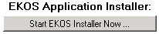 button. Once this process is completed click on to finish the procedure. Afterwards each time you sign on you will only need to click on the link. Once installed you should have the latest version of EKOS (V3.6.00) loaded onto your computer. After clicking on the daily update link if you experience any problems please try clicking on the 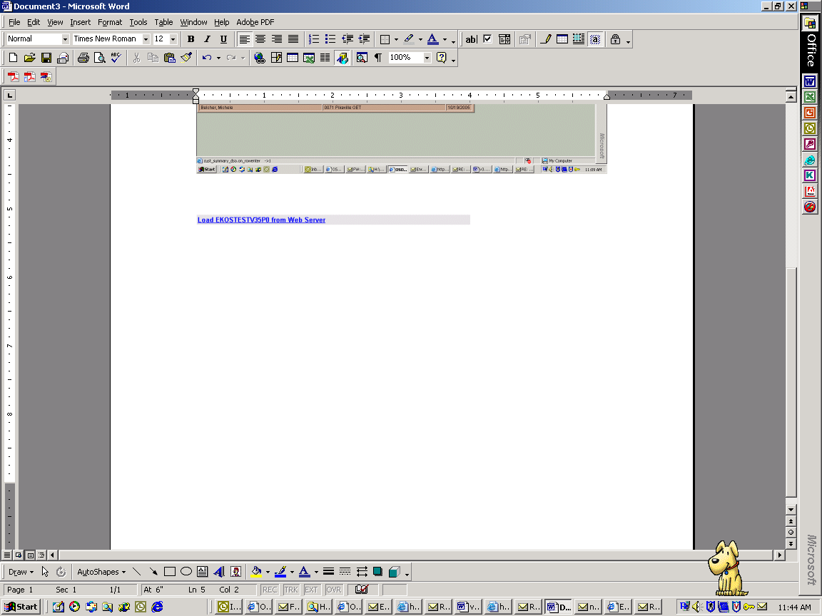 link.

Logging on to EKOS
Once the software has been loaded onto your computer, you will need to type in your username and password and then click on the Login button. This will always log you into your Primary Office.

Mediated Enhancements
- A ‘Print List’ button has been added to the Customer Service Module / Enrollments Tab.

- A ‘Print List’ button has been added to the Customer Service Module / Outcomes Tab.

Reminders
- In order to receive updates to EKOS staff should log out of EKOS nightly.

Continued at the top of column 2

Employ Kentucky Update

Volume 8 , Issue 1 , page 2 EMPLOYKY UPDATE Training DeskAid February 24, 2006

Resolved Issues continued from column 1

- Older Youth enrollments now require the Achievement Objective to be closed prior to exiting the enrollment.

- Lit/Num Testing Custom Tab
Staff can no longer enter invalid numbers and save the record.

- Services Tab
  - Staff can now enter a funded Follow Up service to a closed WIA enrollment.

  - Staff should no longer receive a traceback error message when trying to delete a service.

- Service History Tab / Activity Detail – Service History Web Page Dialog screen / Activity Section
  - The WIB Name is now correctly displaying the WIB associated to the Office field.

- Service History Tab / Labor Exchange Enrollment Detail – Service History Web Page Dialog screen/ Veteran Information Section
  - The Veteran Information is now correctly being displayed.

- Enrollments Tab
  - The transaction information for closing enrollments is being saved when manually exiting WIA/TAA enrollments that are not part of Common Measures.

- Outcomes Tab / WIA Youth 14-21 button section
- Staff can now enter information in the WIA Youth Follow Up Web Page Dialog screen, click on the Submit button then on the Save button without receiving an error message.

- Audit Tab
- The Waiver information is now correctly being displayed when staff makes changes to the existing waiver value that was entered on the Services Tab.

Current Issues
- Regional jobs are not automatically being displayed at the top of the results display list when a job order search is conducted. A workaround for this would be for staff to double click on the “Order #” column heading, which will place the displayed job orders in alphabetical order. Then staff can easily scroll down the list to locate any regional job orders.

- The AFDatabase Error ‘fed_program_cd’ message is still being displayed when some customers are being referred on job orders and in some cases when staff click on the save button after attaching funds to services through the Customer Services Module.

- Staff cannot match a job order to a list.

- In some cases, EKOS will not allow services to be attached to subsequent achievement objectives without a skills goal on younger youth records that have completed goals for the first enrolling service.

- The AFProgramming Error Traceback message is still being received when staff remove the WIA Youth Follow Up information in the Customer Services Module / Outcomes Tab.

Resolved Issues
- The per hour salary amount is no longer dropping the last 0 when it is entered through Self Service and saved to the Mediated EKOS record.

Customer Module
- Objective Tab / Acceptable Job Locations Section
Canada is now correctly being displayed on the resume when it is selected as a job location choice in Mediated.

- Add’l Info Tab / Military Information Section
The ‘From and Thru Date’ fields are now being carried forward on all veteran customer records as appropriate.

- Objective and Skills Tabs
The free form text entries entered in Self Service on the Objective and Skills Tabs are now correctly being displayed in Mediated EKOS.

Customer Services Module
- Achievement Objective Tab
  - Staff can remove an achievement objective from a WIA Youth service when the actual end date has been changed.

Resolved Issues continued in column 2

ABOUT THIS PUBLICATION
Produced by the Office for Employment and Training, EmployKY UpDate is intended to be an information exchange for continuous training on EKOS for all users. Submit topics and tips you think may assist other users to Michele Belcher at 606-433-7721 or email to: michele.belcher@ky.gov or ekos.project@ky.gov. Previous issues of this newsletter can be viewed/printed on the Cabinet website at: http://my.edcabinet.ky.gov/EKOS%20Newsletters/employky_update_newsletters.htm.

Employ Kentucky Update

