
“An information exchange for the Department for Workforce Investment”
Produced by the Office of Employment and Training

EKOS Electronic Manual

Using the HELP Module
EKOS has an excellent electronic manual in the HELP Module. If staff encounter problems or need to review how a process works click on the Help Module and System Help defaults.

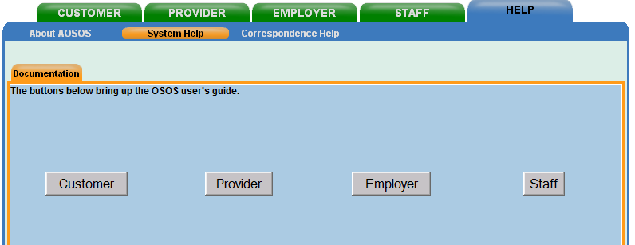

The Help Module contains help on the Customer, Comp Assessment, Employer, Job Order, Provider, Offering, Services and Staff Modules. This manual is very comprehensive and will always contain the most recent updates and is the electronic manual provided for EKOS.

